**CRM**

Customer Relationship Management (CRM) Software category

* Sales Cloud’s sales force automation software helps companies sell smarter, faster and more efficiently by providing everything your sales teams need on one integrated platform.
* Zoho CRM is an online customer relationship management software for managing your sales, marketing, support in a single system. Zoho CRM empowers a global network of over 150,000 businesses in 180 countries to convert more leads, engage with customers, and grow their revenue.
* Freshsales provides a context-driven CRM solution for businesses of all sizes.
* Pega Platform enables to respond to business needs in real time, scale quickly, and evolve as your needs change.
* With Odoo CRM, sales teams are able to analyze the quality of their leads, make faster decisions, and save valuable time by integrating emails from all contacts directly into this fully-integrated app.

Some issues faced for implementing CRM

1. Lack of knowledge and skills in converting data to customer knowledge
2. Lack of motivation for utilising the potential of CRM solution
3. Inadequate performance management parameters
4. Less or insufficient decision-making authority: In order to use CRM concept towards customer centricity, sufficient decision-making power is required to provide customised, responsive and proactive services.
5. Training: Staff lacks training in IT, its applications, the complete use of software and its applications as well as marketing skills, analytical skills, uses of customer information and service skills for implementation CRM.

* As CRM is an organisation wide strategy the entire processes need to be aligned appropriately.

SOME OBSERVATIONS

* According to a study by [Reichheld and Sasser](https://www.tekshapers.com/blog/Important-Role-of-CRM-in-Banking-Sector), banking businesses can observe an improvement in the profit margins by up to 35%, just from the 5% growth in customer retention rate.
* **for every dollar a company spent on a CRM system, they could expect a**[**return on investment (ROI)**](https://nucleusresearch.com/wp-content/uploads/2018/05/o128-CRM-pays-back-8.71-for-every-dollar-spent.pdf)**of about $8.**
* **this study was done in 2011, the ROI ratio was only $5.60 to one, which means we have a 38% increase in just a few years.**
* **$1.1 Trillion - Revenue from CRM solutions that use artificial intelligence**
* **This Statista study shows this to be true. The study shows that in 2018, in the USA, 85% of CRM users expected an**[**improved customer experience**](https://www.forbes.com/sites/louiscolumbus/2018/07/08/how-to-improve-customer-experiences-with-real-time-analytics/?sh=2f0f00426e82)**to be one of the best**[**benefits of CRM software**](https://crm.org/crmland/18-key-benefits-of-crm)**.**
* **12% - CRM adoption growth over the next 5 years**

|  |  |
| --- | --- |
| Year | Revenue  (In billion  U.S. dollars) |
| 2010 | 13.93 |
| 2011 | 16.08 |
| 2012 | 18.09 |
| 2013 | 20.4 |
| 2014 | 23.2 |
| 2015 | 26.29 |
| 2016 | 33.7 |
| 2017 | 41.73 |
| 2018 | 48.23 |
| 2019 | 56.5 |
| 2020 | 69 |

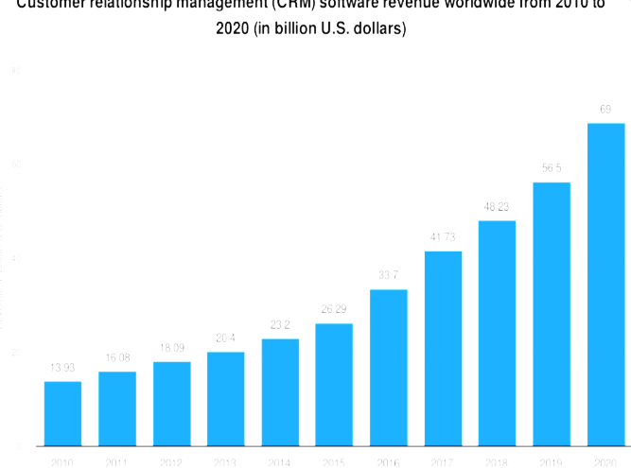

* **General Data Protection Regulation (GDPR)**: Implemented in May 2018, GDPR is a significant regulation impacting CRM systems. It sets strict guidelines for the collection, storage, and processing of personal data of EU citizens. CRM systems must ensure compliance with GDPR by providing features like data encryption, consent management, and the right to be forgotten.

• **California Consumer Privacy Act (CCPA)**: Effective from January 2020, the CCPA provides California residents with greater control over their personal information. Businesses must disclose what data they collect and how it's used, and provide options for consumers to opt-out of data selling. CRM systems must adapt to these requirements to avoid penalties.

• **CAN-SPAM Act**: This U.S. legislation sets rules for commercial email, establishing requirements for commercial messages, giving recipients the right to stop receiving emails, and spelling out tough penalties for violations. CRM systems often include email marketing tools, and compliance with the CAN-SPAM Act is crucial to avoid hefty fines.

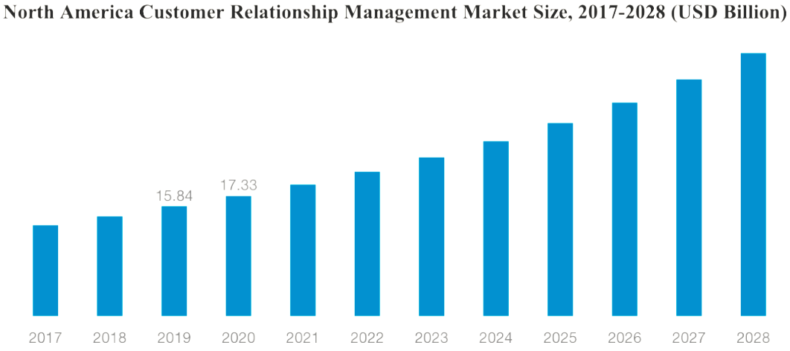

|  |  |
| --- | --- |
| Year | Market Size  (in USD billion) |
| 2017 | 13 |
| 2018 | 14.2 |
| 2019 | 15.84 |
| 2020 | 17.33 |
| 2021 | 18.5 |
| 2022 | 20 |
| 2023 | 21.5 |
| 2024 | 23 |
| 2025 | 25.2 |
| 2026 | 26.8 |
| 2027 | 28.9 |
| 2028 | 30.33 |

**CHECKING AND SAVING ACCOUNT**

* Checking and savings accounts are two of the most basic bank accounts you can open, but they serve different purposes. A checking account is geared primarily toward meeting immediate financial needs, while a savings account is designed mostly for reaching long-term financial goals.
* The average national interest rate for an interest-bearing checking account was [0.07%](https://www.fdic.gov/resources/bankers/national-rates/index.html), compared with 0.46% for a [savings account](https://www.newsweek.com/vault/banking/savings/average-interest-rate-for-savings-accounts/).

OTHER ALTERNATIVES

* A money market account often provides a higher interest rate than a traditional savings account while also allowing you to write checks. As of December 2023, the average national interest rate for a money market account stood at [0.64%](https://www.fdic.gov/resources/bankers/national-rates/index.html), compared to 0.46% for a traditional savings account.
* If simply searching for a place to save money, look into a savings account known as a [certificate of deposit (CD)](https://www.newsweek.com/vault/banking/cds/what-is-a-certificate-of-deposit/). In exchange for an interest rate that’s well above what we get with a traditional savings account, you agree to lock up your money for a certain period (like six months or two years). You might face a financial penalty if you pull money out of a CD before that period ends.
* Another option: [high-yield savings accounts](https://www.newsweek.com/vault/banking/savings/best-high-yield-savings-accounts/) and [high-yield checking accounts](https://www.newsweek.com/vault/banking/checking/best-high-yield-checking-accounts/). High yield-checking accounts, in particular, are harder to come by.

SOME ACTS FOR BETTER IMPLEMENTATION OF ACCOUNTS:

* According to the Federal Reserve’s report on the Economic Well-Being of U.S. Households in 2021, 81% of families are fully banked, 13% are underbanked and 6% are unbanked.[[2]](javascript:%20void(0)) Interestingly, 21.7% of unbanked households indicate they lack a bank account because they don’t have enough money to meet the minimum balance requirements. The second most cited reason was a lack of trust in banks at 13.2%.
* A new federal law known as the **"Check 21 Act"** makes it easier for banks to create and send electronic images of paper checks. Even before Check 21, banks were allowed to process checks electronically when all the banks in the process agreed. Under Check 21, any bank may create a special paper copy—called a "substitute check"—using images of the front and back of an original check. If any bank in the process requires a paper check, another bank can send a substitute check in place of the original.
* **Electronic Fund Transfer Act (EFTA) of 1978** protects consumers in electronic fund transfers, including ATM transactions, direct deposits, and online banking. Provides rights and liabilities of consumers and banks, including error resolution procedures and unauthorized transaction protections.
* **Truth in Savings Act (TISA) of 1991 r**equires banks to provide clear and uniform information about interest rates, fees, and other terms associated with deposit accounts. Its **Impact** is that it ensures consumers are fully informed about the terms of their savings and checking accounts, allowing for better comparison and decision-making.

|  |  |  |
| --- | --- | --- |
|  | Checking Accounts | Savings Accounts |
| Ownership (% of Households) | 95% (2022) | 81% (2022) |
| Average Balance | $5,300 (2022) | $41,600 (2022) |
| Median Balance | $2,000 (2022) | $5,300 (2022) |
| Average Monthly Fees | $5-$12 (2023) | $0-$5 (2022) |
| Interest Rates (Annual) | 0.01%-0.03% (2023) | 0.04%-0.50% (2023) |
| Overdraft fees (Per incident) | $30-$35 (2023) | N/A |
| Online banking usage | 77% (2022) | 65% (2022) |
| Account Closure Rate | 6% (2022) | 5% (2022) |

